A project
Calendar app



CSE 400: Software Development Project IV

SUBMITTED BY
Name | ID | Intake
Md. Imran Hossen | 21222203001 | 41
Rajesh chandra Barman | 21222203002 | 41
Istiak Ahmed Arnob | 21222203028 | 41
Bikash Chandra Ray | 21222203045 | 41
Rohan Rashid | 21222203050 | 41

SUpervised By:

Md. Mahbubur Rahman
Assistant Professor,
Department of CSE

DEPARTMENT OF COMPUTER SCIENCE AND ENGINEERING
BANGLADESH UNIVERSITY OF BUSINESS AND TECHNOLOGY (BUBT)

1st, January, 2025
Abstract

This project, titled "Offline Calendar Application," is a mobile application designed to provide users with a seamless and efficient way to manage their events without requiring an internet connection. Developed for the Android platform using Dart programming language on the Flutter SDK, with SQFlite database for local data storage, the app aims to offer a simple yet powerful solution for organizing and tracking personal events. By focusing on offline functionality, the application ensures that users can rely on it anytime, even in environments with limited or no internet access.
The core functionality of the Offline Calendar Application revolves around enabling users to add, search, edit, delete, and mark events as completed directly on their devices. The calendar interface provides a clean, intuitive view of scheduled events, allowing users to view event details such as start and end times. Users can easily add new events, specifying the date and time, and can also edit or delete events when needed. An important feature is the ability to mark events as completed, which helps users keep track of their progress and avoid overlooking important tasks.
The application stores all event data locally on the device using the SQFlite database, ensuring that user information is kept secure and available for offline use. The app provides a fast, responsive experience with minimal lag, making it suitable for a wide range of users, from those who simply need a basic event manager to those who require more advanced functionalities.
In addition to event management, the app includes a user-friendly search function, allowing users to quickly find specific events by name, date, or other parameters. The app is designed to be fully offline, which makes it especially useful in areas with unreliable internet access, providing the convenience and privacy that comes with storing all data locally. The lack of an internet dependency also ensures that users' data is kept entirely within the app, offering a higher level of security.
The key technology stack for this project includes Dart for the application logic, Flutter SDK for the cross-platform user interface, and SQFlite for local data storage. This combination ensures that the application is lightweight, efficient, and compatible with a variety of Android devices. The use of Flutter SDK also allows for future expansion and customization of the app, ensuring that it can easily be adapted to meet evolving user needs.
In conclusion, the Offline Calendar Application project is designed to address the growing demand for simple, efficient, and offline-compatible solutions for event management. By providing a robust set of features such as adding, searching, editing, deleting, and completing events, the application offers a comprehensive tool for managing personal schedules. The app’s offline capabilities ensure users have continuous access to their calendar data, enhancing productivity and convenience while maintaining data privacy. This project aims to provide a reliable and user-friendly experience for individuals looking to manage their time effectively in any environment.

SI. No | Figure Name | Page
 | Agile Methodology | 11
 | Use Case Diagram | 13
 | 0 Level Diagram | 14
 | Level 1 Diagram | 16
 | Flow Chart | 20
 | Screenshot/Illustration: | 26-27
List of Figures

Table of Contents
Abstract ………………………………….  List of Figures ……………………………  Chapter 1: Introduction ………………...  1.1. Problem Specification/Statement  1.2. Objectives  1.3. Scope  1.4. Organization of Project Report  Chapter 2: Background …………………  2.1. Existing System Analysis  2.2. Supporting Literatures  Chapter 3: System Analysis & Design …  3.1. Technology & Tools  3.2. Model & Diagram  3.2.1. Model (SDLC)  3.2.2. Use Case Diagram  3.2.3. Context Level Diagram  3.2.4. Data Flow Diagram  3.2.5. Database Schema  3.2.6. Algorithms/Flowchart  Chapter 4: Implementation ……………..  4.1. Interface Design/Front-End  4.2. Back-End  4.3. Modules  Chapter 5: User Manual ………………...  5.1. System Requirements  5.1.1. Hardware Requirements  5.1.2. Software Requirements  5.2. User Interfaces  5.2.1. Panel A  5.2.2. Panel B  5.2.3. Login Credentials  Chapter 6: Conclusion …………………..  6.1. Conclusion  6.2. Limitations  6.3. Future Works  References ………………………………..  Appendix A ……………………………… | …………………………..  …………………………..  …………………………..  …………………………..  …………………………..  …………………………..  …………………………..  …………………………..  …………………………..  …………………………..  …………………………..  …………………………..  …………………………..  …………………………..  …………………………..  …………………………..  …………………………..  …………………………..  …………………………..  …………………………..  …………………………..  …………………………..  …………………………..  …………………………..  …………………………..  …………………………..  …………………………..  …………………………..  …………………………..  …………………………..  …………………………..  …………………………..  …………………………..  …………………………..  …………………………..  …………………………..  …………………………..  …………………………..  …………………………..  …………………………..  …………………………..  …………………………..  …………………………..  ………………………….. | …………….… 1  ………………. 2  ……………. 4-5  ……………. 6-7  …………... 8-21  …………. 19-22  …………. 23-27  …………. 27-28  ……………... 29  ……… 30-31
CHAPTER 1
INTRODUCTION

The "Offline Calendar Application" is a mobile app designed to help users efficiently manage and organize their events. Developed using the Dart programming language on the Flutter SDK and employing the SQFlite database for local data storage, the app aims to offer a simple and functional solution for event management that works entirely offline. It enables users to add, edit, search, delete, and mark events as completed, all while ensuring data persistence without requiring an internet connection.
1.1 Problem Specification
In today's fast-paced world, it is increasingly difficult to keep track of events, appointments, and tasks. With the rise of digital calendars, many applications require an internet connection to sync and manage events. However, this can be a limitation in environments with unreliable internet access. Therefore, there is a need for an offline calendar solution that allows users to manage their events seamlessly, regardless of their internet connectivity.
1.2 Objectives of the Project
The primary objectives of the Offline Calendar Application are:
- To provide a user-friendly platform for adding, editing, searching, and deleting events.
- To ensure that the app works offline, making it available for use without an active internet connection.
- To incorporate a feature to mark events as completed for better task tracking and time management.
- To use SQFlite for local data storage, ensuring that event data is stored securely on the device.
- To offer a simple, intuitive design that enhances user experience and makes event management effortless.
1.3 Scope of the Project
The scope of this project includes the design, development, and implementation of an offline calendar application with the following features:
- Adding events with start and end times.
- Searching for specific events by name, date, or time.
- Deleting and editing events.
- Marking events as completed to keep track of progress.
- Storing event data locally on the device using the SQFlite database for offline functionality.
The project does not cover the development of a fully-fledged calendar system with advanced functionalities such as cloud syncing or collaboration features, as the focus is on providing basic offline event management.
1.4 Organization of the Project Report
The report is structured as follows:
- Chapter 1: Introduction provides an overview of the problem, objectives, and scope of the project. It also outlines the organization of the report.
- Chapter 2: Background discusses the analysis of existing systems and presents relevant literature related to event management and offline calendar applications.
- Chapter 3: System Analysis & Design describes the tools and technologies used in the project, including Flutter SDK, Dart, SQFlite, and provides system design models such as Use Case Diagram, Data Flow Diagram (DFD), and database schema.
- Chapter 4: Implementation focuses on the design and development of the system, covering both front-end and back-end development, along with key features of the application.
- Chapter 5: User Manual outlines system requirements, including hardware and software prerequisites, and provides a description of user interfaces and app navigation with relevant screenshots.
- Chapter 6: Conclusion summarizes the findings of the project, highlights its limitations, and suggests future enhancements.
- References lists all the sources referred to throughout the report.
- Appendix A includes additional details such as the project summary, technology stack, features, key implementation details, sample code snippets, testing information, and acknowledgments.

CHAPTER 2
BACKGROUND

2.1 Existing System Analysis
Before developing the Offline Calendar Application, several existing systems were evaluated to understand the strengths and limitations of available calendar apps, particularly those that function offline. These systems can be classified into two categories: traditional manual systems and existing digital calendar applications.
- Traditional Manual Systems (Paper Calendars, Notes)
  - Pros:
    - Simple and easy to use.
    - Accessible to everyone, even without technological devices.
  - Cons:
    - No ability to track event progress or make edits after creation.
    - Can be cumbersome to manage for large numbers of events.
    - Lacks interactivity and the ability to search or organize events efficiently.
- Existing Digital Calendar Apps
  - Pros:
    - Digital calendars allow for easy event management, synchronization, and reminders.
    - Some apps offer cloud synchronization for cross-device access.
    - Most apps provide user-friendly interfaces with built-in event search and editing features.
  - Cons:
    - Many apps require an active internet connection for synchronization.
    - Overcomplicated interfaces and unnecessary features can overwhelm users.
    - Privacy concerns over storing data on the cloud.
Analysis of Existing Systems in Relation to the Offline Calendar Application: The Offline Calendar Application aims to address the gaps left by existing systems, particularly in terms of providing offline functionality and simplifying the user interface. Unlike traditional manual systems, the app enables users to manage their events digitally, offering search, edit, and completion features. Compared to existing digital calendars, the Offline Calendar Application ensures that events are stored locally on the device, removing the reliance on internet connectivity and preserving user privacy.
2.2 Supporting Literature
The development of the Offline Calendar Application draws upon several theoretical and practical concepts in mobile application development and data management.
- Theoretical Foundations
  - Cognitive Load Theory: This theory suggests that reducing unnecessary cognitive load improves the user experience. The simple and clean interface of the Offline Calendar Application minimizes cognitive load, allowing users to focus on managing their events.
  - Offline First Design: This methodology prioritizes building apps that function fully offline and sync data only when an internet connection is available. It is crucial in this project to ensure that users can continue using the app without requiring constant connectivity.
- Technological Foundations
  - Flutter SDK and Dart Programming Language: Flutter is a powerful open-source UI toolkit that enables rapid development of natively compiled applications for mobile, web, and desktop from a single codebase. Dart is the language used for programming with Flutter, chosen for its efficiency in building high-performance apps.
  - SQFlite Database: SQFlite is a database plugin for Flutter used to store data locally on mobile devices. It ensures that user data is stored securely on the device, providing offline capabilities.
- Methodological Approach
  - Agile Development Methodology: Agile development allowed the project team to focus on iterative development, ensuring that features were added progressively and adjusted based on user feedback.
  - User-Centered Design (UCD): The design process was centered around the needs and behaviors of the users, ensuring the app was simple, intuitive, and easy to navigate, particularly for users who may not be tech-savvy.

CHAPTER 3
SYSTEM ANALYSIS & DESIGN

This chapter presents the analysis and design of the Offline Calendar Application. It details the methodologies, tools, and approaches used during the project development lifecycle. The system's design aims to ensure a smooth user experience, intuitive functionality, and scalability for future feature additions.
3.1. Technology & Tools
The development of the Alphabetica app involved a mix of robust tools and technologies to ensure the app was effective, scalable, and user-friendly. Below is an overview of the primary technologies used:
Software Requirements:
- Operating System: Ubuntu 24.04 – Ubuntu 24.04 was chosen for its stability, developer-friendly environment, and compatibility with development tools. The OS supports efficient development and testing of Android applications.
- Android Studio (Version: 2024.1.1) – This integrated development environment (IDE) is tailored for Android app development, providing a suite of tools for app creation, debugging, testing, and performance monitoring.
- Java (Version: 20) – The core programming language used to develop the app. Java is highly compatible with Android Studio and is known for its performance, reliability, and large developer community.
- JDK (OpenJDK, Version: 20.0.2, Corretto) – Java Development Kit (JDK) for compiling and building the Android application. OpenJDK provides the necessary tools to compile Java code into executable formats.
- SQLite (Database) – For local data storage, SQLite was chosen due to its lightweight, fast, and efficient management of data such as user credentials, preferences, and progress.
- XML – XML was used to design the app’s user interface in Android Studio. It provides a clear separation between design and logic, making the app more maintainable and flexible.
Hardware Requirements:
- RAM: 16GB – The development environment required sufficient RAM for smooth performance of Android Studio, which is resource-intensive due to its emulators and debugging tools.
- Processor: Intel Core i7 (10th Generation) – A powerful processor ensured quick execution of development tasks, debugging, and testing.
Other Tools:
- GitHub – Used for version control and collaborative work. GitHub helped manage the project's source code, track changes, and facilitate collaboration within the development team.

3.2 System Development Methodology: Agile
The Agile Development Methodology was chosen for this project due to its flexibility, iterative process, and focus on user feedback. Agile enables faster development cycles, continuous testing, and the ability to adapt to changes during the project. The following key Agile practices were applied:
- User-Centric Development:
Involving users in every sprint ensured that the app met their expectations, especially regarding usability. Feedback was gathered at the end of each sprint to make improvements and adjustments.
- Incremental Delivery:
The project was divided into smaller functional modules, which were developed and tested incrementally. This allowed the team to focus on one feature at a time, such as event creation, deletion, and editing.
- Team Collaboration:
Regular stand-up meetings kept the team aligned on progress, goals, and challenges. These meetings fostered collaboration and ensured that all members were working towards the same objectives.
Efficiency and Benefits for the Project:
- Time Efficiency:
Agile allowed the team to prioritize the core features and deliver a Minimum Viable Product (MVP) early. This MVP included the fundamental functionalities such as adding, editing, and deleting events, which could be enhanced in later sprints.
- Enhanced Quality:
Continuous testing and feedback at the end of each sprint helped identify and address issues quickly. This process ensured that the final product was free from major bugs and met usability standards.
- Scalability:
The Agile methodology facilitated the easy addition of new features, such as multilingual support, event categorization, and offline synchronization. This scalability ensured the app could evolve with user needs.
Workflow:
- Requirement Gathering and Analysis:
The project was divided into smaller tasks based on its core functionalities:
  - Login system for user authentication.
  - Event management features (add, edit, delete).
  - Search functionality for quick access to events.
  - Completion marking to track event progress.
- Planning Sprints:
The development process was divided into sprints. Each sprint focused on specific features:
  - Sprint 1: Database integration and user management.
  - Sprint 2: Development of core event functionalities (add, edit, delete).
  - Sprint 3: UI design and layout implementation using XML and Flutter.
  - Sprint 4: Search and event completion features.
- Design and Prototyping:
During the design phase, low-fidelity prototypes were developed to visualize the app's flow. After user feedback, high-fidelity prototypes were created to finalize the design and ensure the interface was intuitive and age-appropriate.
- Development:
The coding phase involved using Dart with Flutter SDK for cross-platform mobile development. SQFlite was used to handle local data storage, ensuring offline functionality. The backend logic for event management and user authentication was implemented in Java and Android Studio.
- Testing:
The testing process was continuous, with unit tests for individual modules and UI/UX evaluations to ensure the app was easy to navigate and functioned as expected. Regular user testing was also conducted to ensure the app met the needs of the target audience.
- Delivery:
During each sprint, incremental updates were released. The MVP version was delivered early, allowing the team to gather user feedback and iterate on improvements.
- Agile Methodology :

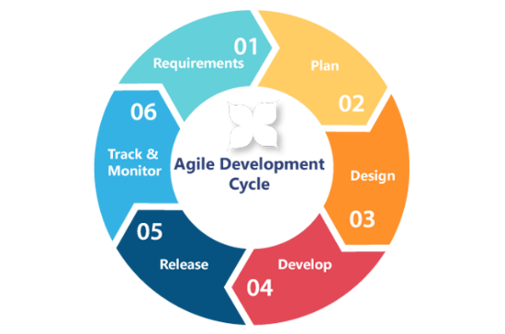

Figure: Agile Methodology

3.3 System Architecture
The system architecture of the Offline Calendar Application is based on the Client-Server Model, where the mobile application (client) interacts with a local database for data storage, retrieval, and manipulation.
- Client (Mobile Application):
  - Frontend: Built with Flutter SDK to ensure cross-platform compatibility, providing a responsive UI for both Android and iOS users.
  - Backend: Handles core functionality such as event creation, deletion, editing, and progress tracking. Data is stored in a local SQLite database, ensuring that the app operates offline.
- Local Storage (SQLite Database):
  - The SQLite database stores user event data, including event titles, start/end times, and completion status. It allows the app to operate without requiring an internet connection, providing persistent data storage.

- Data Flow:
  - The app receives input from users (event details), which is processed by the backend. The data is then stored in the local database. Users can search, modify, and delete events, and the database is updated accordingly.

3.4 System Design
The system design focuses on simplicity and functionality, ensuring that users can easily interact with the app while managing their events efficiently. The design process used low-fidelity wireframes to visualize the app’s key screens and interactions. Based on user feedback, the final design was polished with high-fidelity mockups.
Key Screens:
- Login Screen:
  - Users authenticate with a simple login form (username and password).
  - State Management ensures that the user stays logged in, even after the app is closed.
- Dashboard Screen:
  - Displays upcoming events, with options to add new events or edit existing ones.
  - A search bar allows users to quickly find specific events.
- Event Detail Screen:
  - Users can view, edit, and delete events. Events are marked as completed once finished.
- Settings Screen:
  - Users can configure app preferences, such as event notifications and language settings.

3.4.1. Use Case Diagram
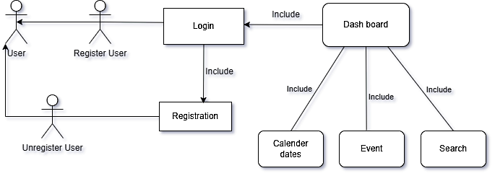

Figure: 3.4.1. Use Case Diagram

3.2.3. Level 0 DFD (Data Flow Diagram)
The Level 0 Data Flow Diagram (DFD) provides a high-level view of the Alphabetica system, illustrating how data flows between external entities, processes, and outputs. At this level, the system is represented as a single process that interacts with users and generates outputs based on their inputs.

Figure 3.3: Level 0 DFD

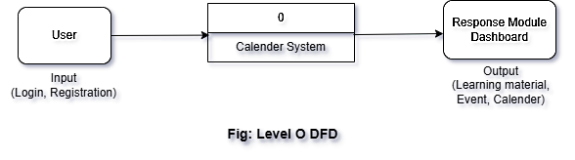

Figure: Level 0 DFD

1. External Entity: User
- Input: The user interacts with the system by providing various types of input:
  - Login or Registration Information: Users enter their credentials to log into the system or register as new users.
  - Selection of Learning Modules: Users choose learning modules, such as learning Bengali vowels, English alphabets, or engaging in math games.
- Output: The system responds to the user with the following outputs:
  - Access to the Dashboard: After login or registration, the user gains access to the app's main interface.
  - Learning Content for the Selected Module: Depending on the user's selection, the system provides relevant educational content such as alphabet lessons or math exercises.
  - Feedback or Results from Activities: For interactive activities like math games, the system provides feedback or results based on the user's performance.
2. Process: Alphabetica System (labeled as 0)
- The entire Alphabetica app is represented as a single process in this diagram, labeled as 0.
- This central process handles all interactions with the user, processes their inputs, and generates appropriate outputs.
- The Alphabetica System is the point where data flows are managed, ensuring that the user’s inputs are processed and that the correct responses are provided.
3. Data Flow
- Input: The user provides inputs to the system such as:
  - Login details
  - Module selections (e.g., Bengali vowels, English alphabet, math games)
  - Interaction with activities (e.g., solving math problems or engaging in educational games)
- Output: Based on the user’s input, the system provides outputs such as:
  - Learning materials (e.g., alphabet and numeral lessons)
  - The main dashboard for navigation
  - Feedback or results from educational activities (e.g., game outcomes, progress).
4. Output Entity: Response (Modules, Dashboard)
- This entity represents the data or information sent back to the user after processing their input. The system’s responses include:
  - Navigation to the Dashboard: Once logged in, users are directed to the main dashboard.
  - Educational Content: This includes modules related to learning alphabets, numerals, and other subjects, as selected by the user.
  - Game Results or Feedback: For interactive modules like games, the system provides the user with results or performance feedback.
Summary of Level 0 DFD:
At this high-level diagram, the Alphabetica system acts as the core process that interacts with users by receiving inputs (such as login credentials, module selections, and game interactions) and sending outputs (like educational content, feedback, and navigation to the dashboard). It provides a clear overview of how the system processes data and the flow of information between users and the application.

3.2.4. Level 1 DFD (Data Flow Diagram)
The Level 1 Data Flow Diagram (DFD) for the Alphabetica project breaks down the major sub-processes and their interactions with data sources. This diagram provides a more detailed view of how the data flows within the system, focusing on core operations such as user authentication, dashboard display, module selection, content delivery, and progress tracking.

Figure 3.4: Level 1 DFD

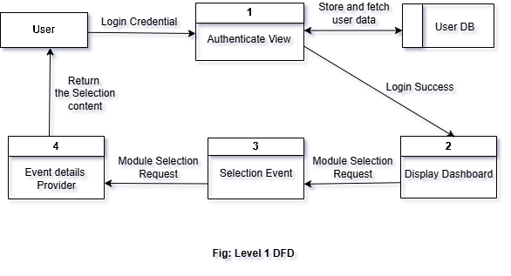
Figure: Level 1 DFD

External Entity: User
The User is the central external entity interacting with the system. The key inputs from the user include:
- Login Details: To authenticate and gain access to the system.
- Module Selection: To start the learning process by selecting specific educational modules.

Sub-Processes and Data Flow
1. Authenticate User
- Inputs: Login credentials (username and password) provided by the user.
- Outputs: Authentication status (success or failure).
- Description: This process validates the user’s credentials by querying the User Database. Based on the result, it either grants access or prompts the user with an error message.
- Data Flow:
  - User → Authenticate User → User Database → Authenticate User → User
    - The system queries the User Database for the entered credentials, then returns either a successful authentication status or a failure message to the user.
2. Display Dashboard
- Inputs: A successful authentication status.
- Outputs: Dashboard options displayed to the user (e.g., list of modules or settings).
- Description: After a successful login, the system fetches and displays the dashboard options to the user, allowing them to navigate to various sections such as available learning modules or settings.
- Data Flow:
  - Authenticate User → Display Dashboard → User
    - Upon successful authentication, the system retrieves the relevant dashboard options and displays them to the user.
3. Select Module
- Inputs: The module selected by the user.
- Outputs: A module request sent to the Provide Content process.
- Description: Captures the user’s module selection and sends a request to fetch the relevant content for the selected module.
- Data Flow:
  - User → Select Module → Module Request
    - The user’s selection of a module triggers the system to initiate a request to retrieve content from the appropriate data source.
4. Provide Content
- Inputs: A selected module request.
- Outputs: The corresponding module content displayed to the user.
- Description: This process retrieves the content for the selected module from the Module Data Store and presents it to the user in the form of text, images, videos, or interactive elements.
- Data Flow:
  - Select Module → Provide Content → Module Data Store → Provide Content → User
    - The module request is sent to the Module Data Store, which holds all content for the different learning modules. The relevant content is then sent back to the user.
5. Track Progress (Optional)
- Inputs: User activity (e.g., completion of lessons, tasks, or games).
- Outputs: Updated progress stored in the User Database.
- Description: This optional process monitors the user’s learning progress (such as completed lessons or activities) and saves it in the User Database for future reference.
- Data Flow:
  - User → Track Progress → User Database
    - User activity, such as completing a lesson, triggers the Track Progress process, which updates the User Database with progress data.

Data Stores
1. User Database
- Contents: Stores user credentials (username and password) and progress data (completed lessons, activities, etc.).
- Interacts with:
  - Authenticate User: Used to validate user credentials during login.
  - Track Progress: Stores the user’s learning progress after completing modules or activities.
2. Module Data Store
- Contents: Stores educational content for all modules, user preferences, and related data.
- Interacts with:
  - Provide Content: Supplies the relevant content for the selected module.

Summary of Level 1 DFD:
In this detailed view, the system's processes interact with two primary data stores: the User Database (for storing user data and progress) and the Module Data Store (for storing educational content). The key sub-processes include user authentication, displaying the dashboard, module selection, content delivery, and progress tracking. The system processes the user’s inputs, retrieves the necessary data from the stores, and delivers the outputs efficiently, ensuring a smooth learning experience.

3.2.5. Database Schema
The Alphabetica app uses a simple database schema with a User Table to handle user login and registration functionalities. The table consists of columns that store essential data for managing user accounts.

Figure 3.5: User Table
Column Name | Data Type | Constraints | Description
id | INTEGER | PRIMARY KEY, AUTOINCREMENT | Unique identifier for each user.
username | TEXT | UNIQUE, NOT NULL | Stores the user's unique username.
password | TEXT | NOT NULL | Stores the user's password.

Table Functionality:
The User Table is responsible for:
- User Registration:
  - When a user registers, the app stores their unique username and password in the table.
- User Login:
  - During login, the app verifies the entered username and password against the stored data in the table to authenticate the user.
Description of Each Column:
- id: This column serves as the unique identifier for each user. It is automatically incremented with each new user registration.
- username: A unique, non-null field that stores the user's chosen username. The UNIQUE constraint ensures no two users can have the same username.
- password: This field stores the user’s password, ensuring secure login functionality. The NOT NULL constraint ensures that a password must be provided during registration.

3.2.6. Flowchart

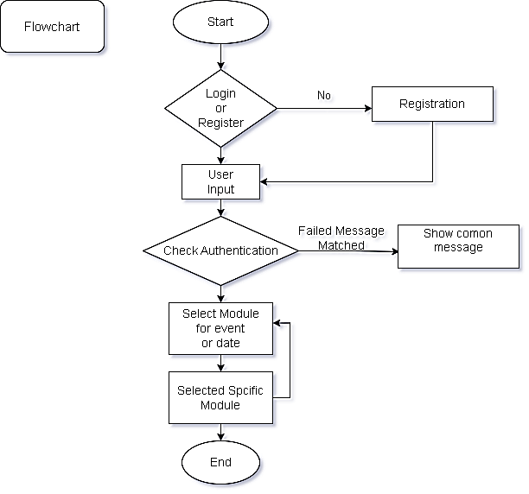

Figure: Flowchart

Description of the Flowchart:
- Start: The process begins.
- Decision for Login or Registration: The system asks whether the user wants to log in or register.
  - Login Process: The user inputs their username and password. The system authenticates the credentials and proceeds to either the dashboard or an error message.
  - Registration Process: The user inputs registration details (username, password, and confirmation). The system validates the registration and either stores the data or shows an error message.
- Content Selection: After successful login or registration, the user selects a learning module. The system fetches content based on the selection and displays it.
- End: The process concludes.

CHAPTER 4
IMPLEMENTATION

4.1. Interface/Front-End Design
The front-end design of Alphabetica was crafted to ensure a smooth, intuitive user experience. Here are the key aspects:
- Login and Registration Forms: These forms are designed with simplicity in mind, using minimal fields to avoid overwhelming the user. The standard Android UI components like EditText (for input fields) and Button (for actions) are used.
- Dashboard: After a successful login, the user is directed to a dashboard that is both clean and simple. The dashboard displays the available content modules, each represented by either a card or button, making it easy for users to select their desired content.
- Colors and Themes: A consistent color palette is employed throughout the app, which ensures a professional look while enhancing the user experience. The color scheme also helps maintain a balance between aesthetics and usability.
4.2. Interface/Back-End Design
The back-end of the app is responsible for processing data and ensuring seamless interaction between the user interface and the app's logic.
- Login and Registration Functionality: User credentials are stored locally using SharedPreferences. This choice enables lightweight, efficient data management without the need for external databases. The system verifies credentials during login, giving immediate feedback on success or failure.
- Data Validation: During registration, the system checks that fields like username, password, and confirm password are correctly filled out. It prevents errors such as empty fields or mismatched passwords, providing users with clear validation messages.
- Content Display: After the user successfully logs in, the app fetches and displays content from predefined modules stored within the app. The content is dynamically updated to provide a smooth and responsive user experience.
4.3. Modules/Features
The Alphabetica app incorporates the following modules and features:
- User Authentication:
  - Login: Verifies the user's credentials and grants access to the app upon successful validation.
  - Registration: Allows new users to create an account by providing a username, password, and confirm password.
  - Error Feedback: Provides clear and helpful error messages for failed login attempts or when passwords don't match during registration.
- Dashboard:
  - Displays the available learning modules, providing users with a central hub for navigating the app's features.
  - Acts as the main control center where users can easily choose which content to explore.
- Content Modules:
  - Enables users to explore predefined educational or informational content, such as learning materials related to language or games.
- Local Data Storage:
  - Utilizes SharedPreferences to store and manage user credentials locally. This removes the need for a server-side database, simplifying the architecture and improving performance.
- Error Handling:
  - The app ensures a smooth user experience by providing meaningful feedback when issues arise (e.g., invalid login credentials or incomplete registration). This helps prevent user frustration and guides them toward resolution.
CHAPTER 5
USER MANUAL

5.1. System Requirements
5.1.1. Hardware Requirements
To ensure smooth development and optimal performance, the following hardware configurations are recommended for the Alphabetica project:
- Processor: Intel Core i7 or equivalent for fast processing and multitasking.
- RAM: 16 GB (minimum) to handle the demands of Android Studio and other development tools.
- Storage: At least 10 GB of free disk space to accommodate the app’s source code, resources, and Android Studio installation.
- Display: A screen resolution of 1280x720 pixels or higher for an optimal development and testing environment.
- Device: Android device running Android 8.0 (Oreo) or higher to ensure compatibility with the app and enable real-time testing.
5.1.2. Software Requirements
The following software configurations are necessary to run and develop the Alphabetica app:
- Operating System: Ubuntu 24.04 or Windows 10/11 (for development environment).
- Development Environment:
  - Android Studio Arctic Fox or later for app development and testing.
  - OpenJDK 20.0.2 for Java-based development.
- Android Version: The app supports devices running Android 8.0 (Oreo) or higher.
- Tools and Libraries:
  - SharedPreferences API for lightweight local data storage, which stores user credentials and preferences.
  - XML for designing the front-end layouts.
- Additional Software:
  - ADB (Android Debug Bridge) for testing and debugging the app on physical devices.
  - Emulators (built into Android Studio) for running and testing the app without requiring physical devices.

5.2. User Interfaces
This section provides an overview of the key user interfaces of the Alphabetica app, outlining their functions and flows.
5.2.1. Login Panel
The Login Panel is the entry point to the application where users authenticate themselves to gain access to the app’s features.
- Inputs:
  - Username: A unique identifier for the user.
  - Password: A secure key linked to the username.
  - Confirm Password: Ensures the password is entered correctly during registration.
- Process:
  - User enters their login credentials.
  - If valid, the user is navigated to the Dashboard.
  - If invalid, an error message is displayed.
- Outputs:
  - Success: Navigates to the Dashboard.
  - Failure: Displays a login error.
- Features:
  - User authentication with validation and error handling.
5.2.2. Dashboard Panel
The Dashboard Panel serves as the central navigation hub of the app, where users can select modules (e.g., Arabic, English, etc.).
- Inputs:
  - User selects a specific module (e.g., Arabic, English).
- Process:
  - User clicks on a desired module.
  - The app navigates to the selected module (e.g., Arabic, English).
- Outputs:
  - Success: Opens the corresponding module (e.g., English Panel).
- Features:
  - Dynamic navigation between modules for an easy user experience.
Example: English Panel (Module)
The English Panel is a module focusing on the English alphabet.
- Inputs:
  - User clicks on an English alphabet or number.
- Process:
  - The app plays an audio file for the selected alphabet or number.
  - The selected option is highlighted visually.
- Outputs:
  - Audio playback of the selected option.
  - Visual feedback (highlight).
5.2.3. Back Navigation
The Back Button allows users to return to the Dashboard Panel from any module.
- Inputs:
  - User clicks the back button.
- Process:
  - Clears the current activity stack using flags (FLAG_ACTIVITY_CLEAR_TOP and FLAG_ACTIVITY_NEW_TASK).
  - Navigates back to the Dashboard Panel.
- Outputs:
  - Smooth transition back to the Dashboard.
5.2.4. Persistent State Management
The app manages persistent state using SharedPreferences, which saves the state of the last selected item in a module (e.g., in the Arabic Panel).
- Inputs:
  - User selects an item within a module.
- Process:
  - Save the selected item’s ID in SharedPreferences.
  - Upon revisiting the module, the app restores the previous selection.
- Outputs:
  - Restored UI with the previously selected item, preserving user preferences across sessions.

5.2.5. Screenshot/Illustration:

Sign up: | Log in: | Dashboard:
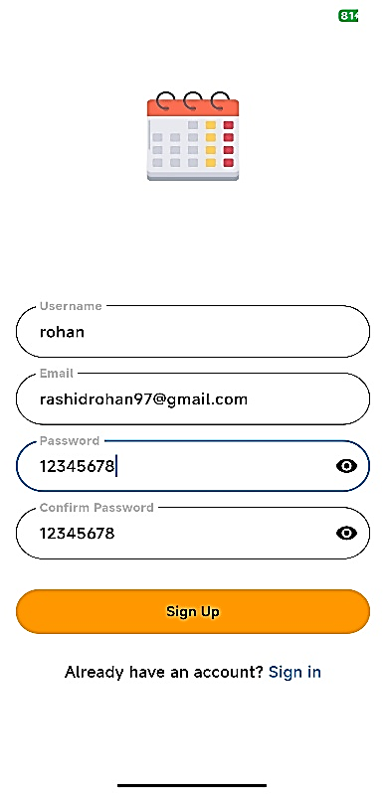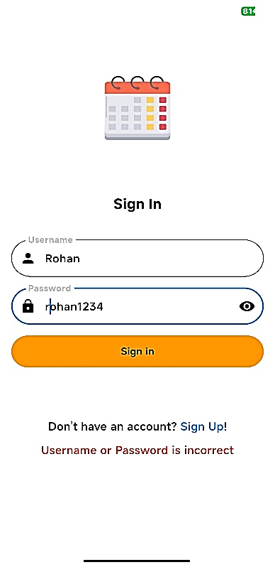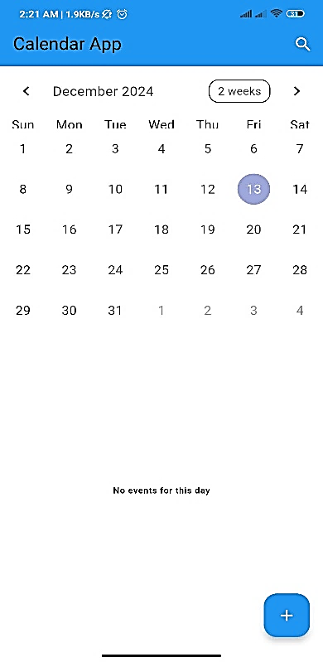

+ Add Event: | Event Added: | Event Details:
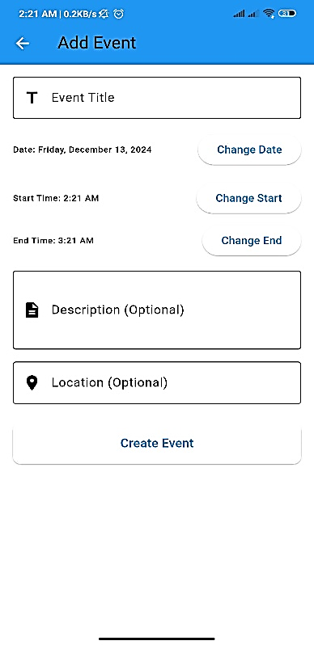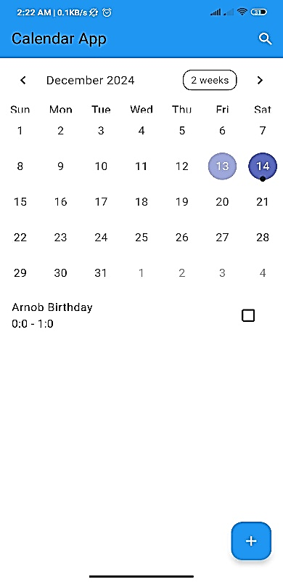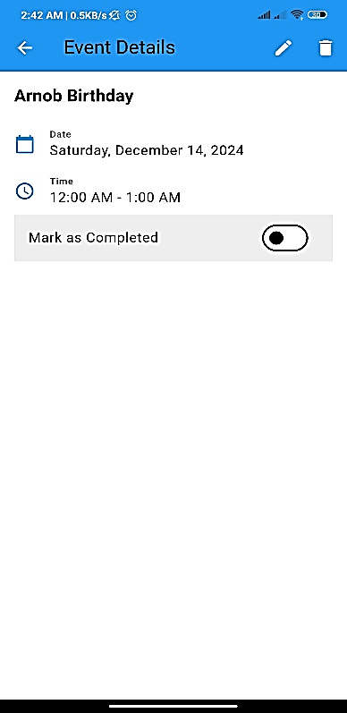

Search Event: | Delete Event: | After Delete Event:
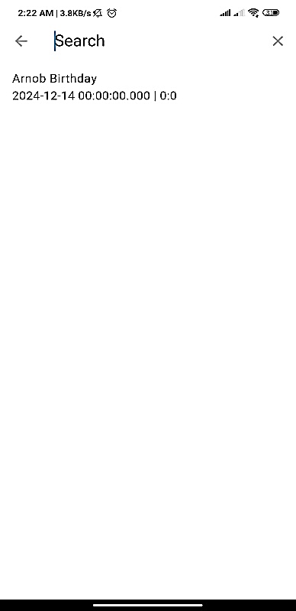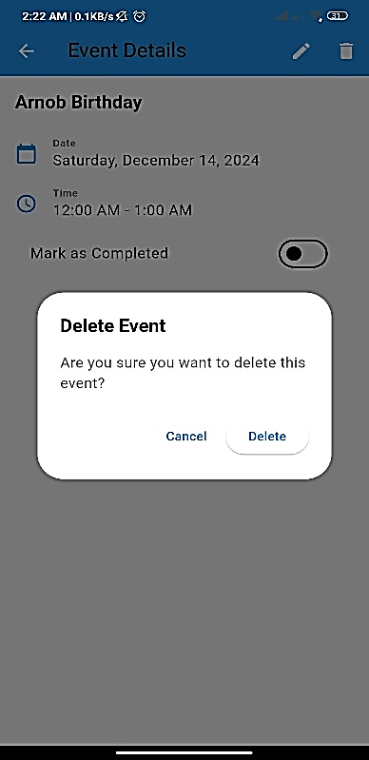

CHAPTER 6
CONCLUSION

6.1. Conclusion
The Alphabetica project successfully fulfills its objective of providing an engaging and educational platform for learning alphabets in various languages. Through the use of persistent data storage with SharedPreferences, dynamic audio playback, and an intuitive user interface, the application offers a smooth and enjoyable learning experience. The project provided the team with valuable knowledge in Android development, user interface design, and efficient resource management. This hands-on learning experience has been essential in gaining a deeper understanding of how to build scalable and interactive mobile applications.
6.2. Limitations
While Alphabetica meets its primary goals, there are some limitations:
- Single User Profile: The application currently supports only one user profile and does not offer the capability for multiple user accounts or personalized experiences.
- Hardcoded Audio Files and Layouts: The use of hardcoded audio files and layouts limits the app’s flexibility, making it difficult to update or expand content without modifying the app’s source code.
- No Online Synchronization: The app lacks synchronization capabilities with cloud storage, which means all data is stored locally on the device and is not accessible across different devices.
- Limited Accessibility: The app does not offer sufficient accessibility features, such as text-to-speech support or options for larger fonts, which could hinder users with disabilities.
6.3. Future Works
To address the limitations and enhance the app, the following improvements are planned:
- Support for Multiple User Profiles: Future versions will allow users to create multiple profiles and track individual progress, making the app more versatile.
- Addition of More Languages and Learning Modes: Expanding the app to support additional languages and customizable learning modes will enhance its usability for a broader audience.
- Cloud Storage Integration: Adding cloud storage support will enable real-time synchronization of user data across devices, ensuring a seamless experience.
- Improved Accessibility Features: The app will be made more inclusive by adding features like text-to-speech support, font size adjustments, and color contrast options.
- Gamification: Incorporating gamified elements, such as quizzes and challenges, will make learning more interactive and enjoyable for users.
- Analytics for Progress Tracking: The integration of analytics will help track user progress and tailor the learning experience based on individual behaviors and preferences.

References
- Android Developers. "SharedPreferences." Android Documentation, Google, developer.android.com/reference/android/content/SharedPreferences. Accessed 10 Dec. 2024.
- Stack Overflow Community. "How to Save and Retrieve the Last Selected State in Android?" Stack Overflow, stackoverflow.com. Accessed 10 Dec. 2024.
- JavaTpoint. "Android MediaPlayer Example." JavaTpoint, www.javatpoint.com/android-mediaplayer-example. Accessed 9 Dec. 2024.
- Scribbr. "MLA Citation Generator." Scribbr: Your MLA Citation Guide, www.scribbr.com/citation/generator/. Accessed 12 Dec. 2024.
- GeeksForGeeks. "How to Build a Multi-Language Android Application?" GeeksForGeeks, www.geeksforgeeks.org/how-to-build-a-multi-language-android-application/. Accessed 8 Dec. 2024.
- Draw.io. Diagrams for Process Flowcharts and DFDs, diagrams.net. Accessed 7 Dec. 2024.
- XML Layout Examples and Code Snippets. "Android UI Design Principles." Medium: Mobile UI Design Tips, medium.com. Accessed 6 Dec. 2024.

Appendix A
The Appendix A for the Alphabetica project contains important supplementary information that expands on key aspects of the development process. Here's a structured breakdown of the contents:
A.1. Project Summary
Alphabetica is an interactive educational Android app designed to help users learn alphabets from various languages. The application enables users to listen to the pronunciation of letters by tapping on them, with the selected letter being highlighted for visual feedback. It incorporates SharedPreferences to retain the user’s last state, ensuring that their progress is saved and resumed after reopening the app.
A.2. Technology Stack
- Programming Language: Java
- IDE: Android Studio
- Database/Storage: SharedPreferences (local storage for user data)
- Media: MediaPlayer (for audio playback of letter pronunciations)
- UI Design: XML (for layouts), following Material Design principles for intuitive and user-friendly interfaces.
A.3. Features and Functionalities
- Login and Registration:
  - Secure login and registration process using SharedPreferences.
  - Fields for Username, Password, and Confirm Password to ensure secure access.
- Interactive Alphabet Modules:
  - Multiple language panels to choose from.
  - Each panel contains alphabets that can be tapped to play audio pronunciations.
- State Persistence:
  - Retains the last selected letter (highlighted with a red background) even after the app is closed and reopened.
  - Uses SharedPreferences to save and restore the last activity state.
- Navigation:
  - Provides a back button for easy navigation to the home page.
  - Clears the activity stack efficiently to prevent reopening previous screens unnecessarily.
A.4. Key Implementation Details
- Audio Map: Maps TextView IDs to corresponding audio files for the letter pronunciations.
- Color Management: Dynamically resets button colors to maintain a clean and interactive user interface.
- Back Button Navigation: Uses Intent flags to navigate back to the home screen, clearing the activity stack and preventing app restart.
- MediaPlayer Management: Proper management of MediaPlayer resources to avoid memory leaks.
A.5. Sample Code Snippets
- State Persistence Using SharedPreferences: This snippet demonstrates how the app saves and retrieves the last selected letter using SharedPreferences.
- Audio Playback Using MediaPlayer: This snippet illustrates how the app plays the audio pronunciation of each letter using the MediaPlayer class.
A.6. Testing Information
- The app has been tested on Android 11 and above.
- Verified state persistence and audio playback across multiple devices.
- Ensured UI responsiveness and proper functionality of the buttons.
A.7. Acknowledgments
- Special thanks to Md. Mahbubur Rahman, Assistant Professor, Department of CSE, Bangladesh University of Business and Technology, for his valuable guidance.
- Gratitude extended to peers and online communities who provided assistance, code examples, and troubleshooting tips, which were crucial for the development of the app.

